Q2. Catcher f06c9fdf’s Strengths and Weaknesses

**Strengths:**

* Gets more strikes called on pitches thrown in the upper inside part (right-handed batter perspective) of the strike zone more often than other catchers in the league

*See “All Pitches” Image*

* Frames pitches thrown by right-handed pitchers outside of the upper outer part of the strike zone better than other catchers

*See “Pitcher Side” Image*

* Gets more strikes called on pitches thrown to left-handed batters in the upper part of the strike zone more often than other catchers

*See “Batter Side” Image*

* Frames changeups thrown outside of the upper inside part of the strike zone and sliders thrown outside of the upper outside part of the strike zone better than other catchers

*See “Pitch Types” Image*

**Weaknesses:**

* Gets more balls called on pitches thrown to the lower and outer part of the strike zone more often than other catchers in the league

*See “All Pitches” Image*

* Frames pitches below the strike zone worse than other catchers

*See “All Pitches” Image*

* Frames cutters and fastballs poorly

*See “Pitch Types” Image*

**All Pitches**

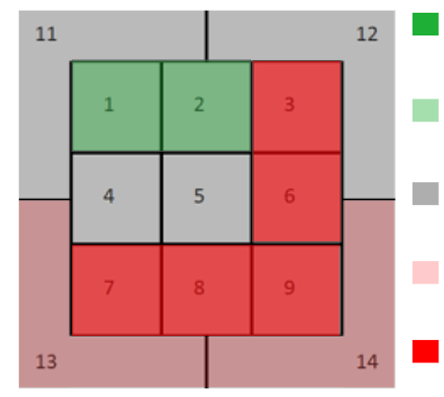

Catcher f06c9fdf better than other catchers at getting non-swinging strikes called

***Strikes called 5%+ more often***

Catcher f06c9fdf better than other catchers at getting non-swinging strikes called

***Strikes called 2-5% more often***

Catcher f06c9fdf about the same as other catchers at getting non-swinging strikes called

***Strikes called within +/- 2% of all other catchers***

Catcher f06c9fdf weaker than other catchers at getting non-swinging strikes called

***Strikes called 2-5% less often***

Catcher f06c9fdf weaker than other catchers at getting non-swinging strikes called

***Strikes called 5%+ less often***

Strike Zone: Catcher’s Perspective

**Pitcher Side**

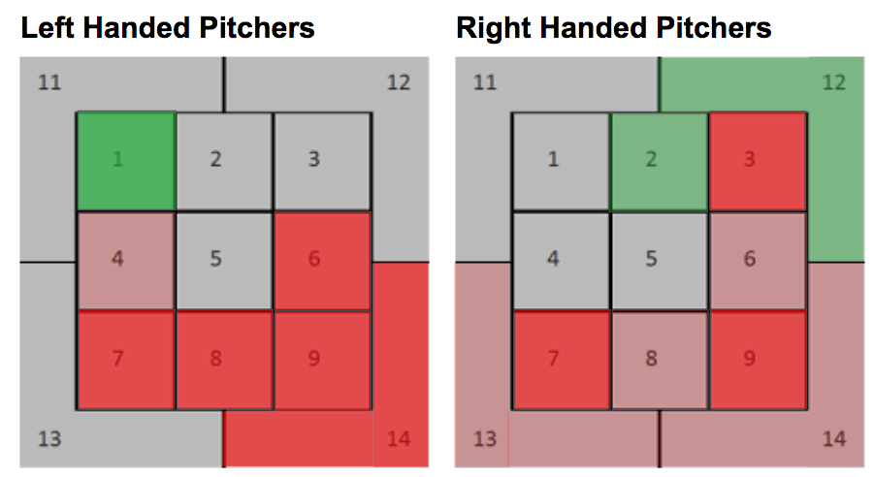

**Batter Side**

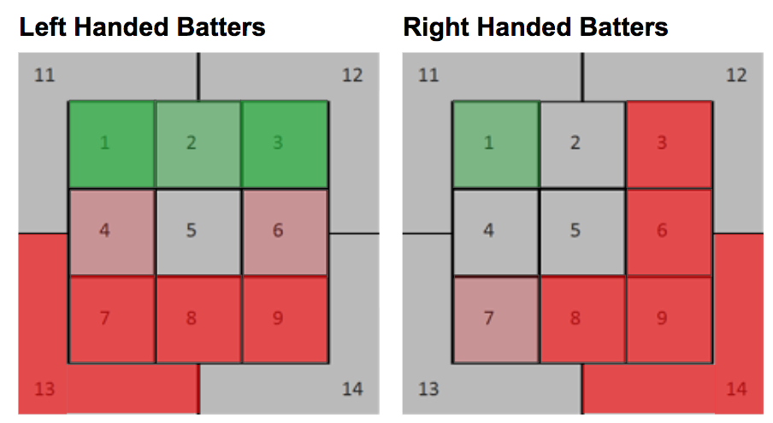

**Pitch Type**

